What Defines You?
If someone were to ask you to describe yourself, how would you do it? What emphasis would you place the highest in rank in your description of yourself? Would you talk about what you do for a living? Sometimes we naturally define ourselves as such. This is why we ask when first meeting someone, “what do you do for a living?” But we cannot possibly be defined simply by what we do for a living. For what about those who cannot make a living?
Would you talk about your heritage? Other times we define ourselves as being a part of a specific people group or culture. The thing with this is that if culture changes, then what can we anchor ourselves onto if culture changes?
If every culture is, in and of itself, salvifically hopeless, then the fullness of one’s identity in Tribal culture, Asian culture, American culture, Viking culture, or any culture, is hopeless. Culture cannot save us, nor does it define us.
Logically speaking, this looks like the following:

1. All cultures in and of themselves are salvifically hopeless.
2. There are people who place the fullness of their identity in their culture
3. Therefore, those people who place the fullness of their identity in their culture are salvifically hopeless.

Because a culture can completely change from what it began as, it can therefore not be timeless (given enough time, change in a culture is inevitable). If something is removed from that culture, or added to it, then it is a different culture altogether. Winfried Corduan writes,

By the term diffusion, I mean the distribution of cultural items apart from people changing their place of residence, e.g., by trade or imitation… On a more serious side, we see the global spread of cell phones. An even more significant example is the adoption of European business culture all over the world, which has included standard forms of dress, acceptance of common standards of measure, a protocol regulating standards of courtesy, sharing ‘business cards,’ deference to authority, and the manner in which negotiations are carried out, as well as some tacit agreements on what is and what is not legitimate business practice.

Here we see obvious cases where behaviors are added or removed from cultures. Because any specific culture having additions and subtractions to that culture, such a culture cannot therefore by nature, be timeless. Not only this, but the culture had a specific time of birth, which also renders it to be finite. Because every culture is bound by time, this means that any specific culture cannot be the thing which one places his hope in. If we place our hope in something that has a life expectancy, then our hope will die with it.

1. If people place their hope in something that has a life expectancy, then their hope will die with it.
2. There are people who place their hope in their culture (which has a life expectancy).
3. Therefore, their hope will die with their culture.

This does not mean that culture is meaningless. In the First Nations Version of the New Testament, John the Apostle writes in Revelation 7:9-10, “After this I saw a great crowd of people, too many to count, from every nation, tribe, clan, and language. They were standing before the seat of honor and before the Lamb, dressed in pure white regalia, holding palm tree branches in their hands. They lifted their voices and shouted, ‘The power to set us free and make us whole belongs to the Great Spirit who sits upon the seat of honor, and to the Lamb’” (FNV). So, John recognized all tribes and nations and clans and languages, who were in heaven. In other words, there must be an element of such things that are interwoven in the fabric of our being, but these are still not our identity…

Identity
Identity that is truly significant can only be found in Him who is eternal, that is, Christ. Notice the above Bible passage says that every tribe, clan, nation, and language, which means, “You are all one in Christ Jesus.”

1. Identity in Christ is where one finds true hope.
2. Some people do not have their identity in Christ, but only identify in their heritage and culture.
3. Therefore, some people are without true hope.

One finds true hope in Christ alone because He alone is God and is timeless. Identity that cannot be taken away from a person can only be found in something that is not invented by man. This is important to understand because that which we identify in determines our eternity.
1. If my identity is in Christ alone, then I will live forever.
2. My identity is in Christ alone.
3. Therefore, I will live forever.

This is the reason why John witnessed all these people before the Great Spirit who sits upon the seat of honor. Because they (we) all have their (our) identity in Christ alone. True identity is in Christ first and in Him alone. One’s value and significance as a human being does not come from where he came from, as in where he was born, but one’s value comes from Jesus, who created him. A person’s value and significance comes from the fact that he was created out of love by our Creator. This means that you are intrinsically valuable as a human being.

The True Hope
Heritage or culture offers no ultimate hope.
Jesus offers something greater: Eternal life! Everyone acknowledges that there is right and wrong and that it all must be made right. This is a good start. The Bible teaches that all will come to the place of judgment, because all have failed Creator (Romans 3:23), but that those who have Jesus (1 John 5:11-12), will not fall under this judgment because Jesus takes away our sins (moral failures) (Ephesians 2:8-9; Romans 6:23; John 1:29). This is where our expectant hope lies as followers of Christ. In Jesus alone we find real meaning, value and purpose for our lives. He desires a personal relationship with all people…. With you! “The Great Spirit loves this world of human beings so deeply he gave us his Son—the only Son who fully represents him. All who trust in him and his way will not come to a bad end but will have the life of the world to come that never fades away, full of beauty and harmony. Creator did not send his Son to decide against the people of this world, but to set them free from the worthless ways of the world.” (John 3:16-17 FNV).
Respond by placing your trust and hope in Him today: “If you will lift up your voice and make it known that Creator Sets Free (Jesus) is the Honored Chief over all the earth, and trust in your heart that the Great Spirit has raised him from the dead, you will be set free and made whole” Romans 10:9 FNV). Doing this marks the beginning of your new relationship with your Creator!

Good questions to think about:
What do I really identify in, first and foremost?
Where do I place my hope on a day to day basis?
Does my value as a human being really exist in my heritage or culture, or is there more to it?
Do I truly realize that I am defined by more than where I was born?
If I am intrinsically valuable, would suicide ever be a true to life option?
Do I realize that Creator truly loves me? Is it an accident or coincidence that I have read this?
For more information and material, visit:

https://apologeticsandevidence.blogspot.com/2022/10/using-apologetics-and-hermeneutics-in.html

www.facebook.com/ApologeticsAndEvidence/

(Permission is granted to make copies of this pamphlet and to distribute them, provided this is done free of Charge and without altering the content.) | 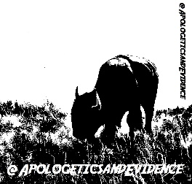

With Whom Do You Identify?

“Contend for the faith that was once
for all delivered to the saints.”
~Jude 3
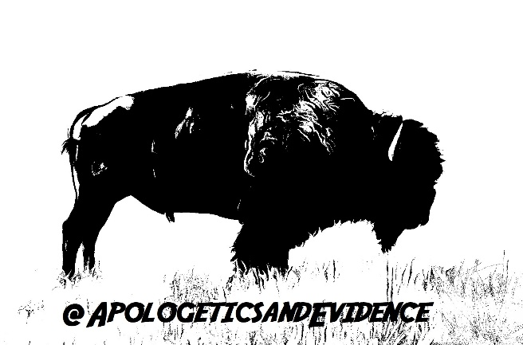

Winfried Corduan, In the Beginning God: A Fresh Look at the Case for Original Monotheism (Nashville: B&H Publishing Group, 2013), 147; emphasis added.
Scripture quotations are reproduced from First Nation Version: An Indigenous Translation of the New Testament, copyright 2021 by rain ministries, Inc. Used by permission of InterVarsity Press. All rights reserved worldwide. www.ivpress.com
Galatians 3:28.
John 1:3.

